Project Name: Bluetooth Low Energy

Technical aspects: SPI, BLE, Interrupt, AT commands, communication with iOS App.

The Bluefruit breakout board’s firmware are written by Adafruit Industries. Used internal Adafruit SPI library to communicate with BLE board. AT commands are transmitted encoded in their SDEP (Simple Data Exchange Protocol).

Firmware are written by Adafruit

Specs:

* ARM Cortex M0 core running at 16MHz
* 256KB flash memory
* 32KB SRAM
* Transport: SPI at up to 4MHz clock speed
* 5V-safe inputs (Arduino Uno friendly, etc.)
* On-board 3.3V voltage regulation
* Bootloader with support for safe OTA firmware updates
* Easy AT command set tunneled over SPI protocol to get up and running quickly
* 23mm x 26mm x 5mm / 0.9" x 1" x 0.2"
* Weight: 3g

Page: https://www.adafruit.com/product/2633

Tutorial: <https://learn.adafruit.com/introducing-the-adafruit-bluefruit-spi-breakout/introduction>

Components:

Sharp distance sensor: GP2Y0A21YK0F Distance Measuring Sensor Unit Measuring distance: 10 to 80 cm Analog output type

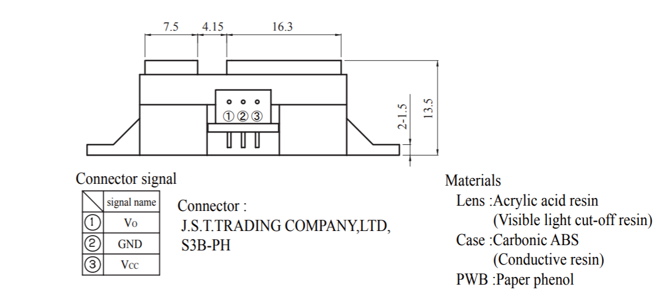

1. Vo – output: -0.3 to VCC+0.3
2. Vcc : 5V
3. Gnd: Gnd
4. Add a by-pass capacitor of 10uF or more between Vcc and Gnd.

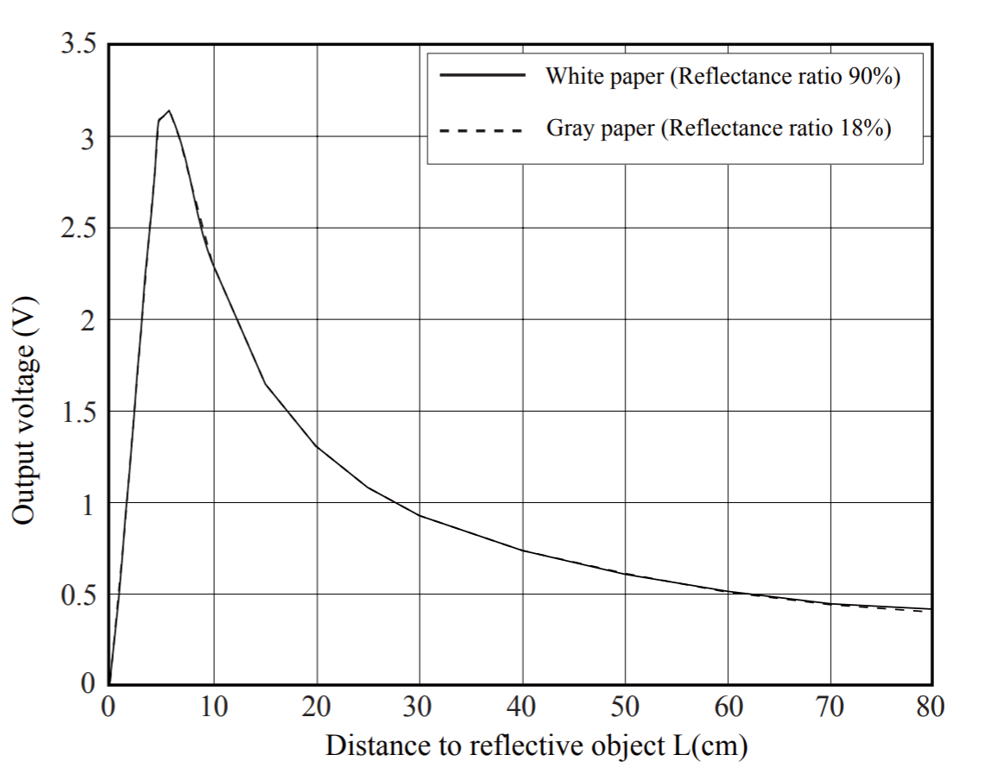

Formula for the above graph extracted from excel:

